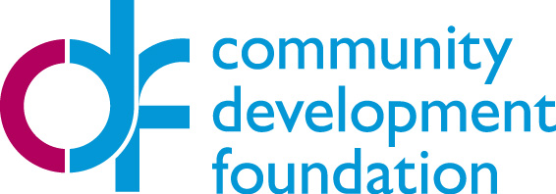
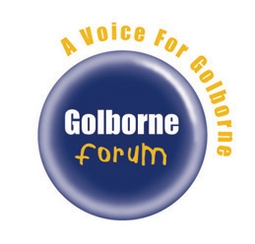

Golborne Community First Panel Fund: Project Proposal Form
Please fill in the project proposal form below and then send it to the Golborne Community First Panel. You may wish to discuss the outline of your project with the panel for some initial feedback before submitting your proposal. Before completing this form please read the Application Guidance.
The deadline is Monday 3 March, 5pm.
About your group

Name of your Group:
Main contact:
Position in group:
Address:
Postal code:
Email address of main contact:
Main telephone number:

About the project
Project Title Give your project a short title so it can be easily identified (Max 10 words)
Project Summary. Please describe your project (No more than 150 words):
Which of local priorities identified for your ward does this project address? (See the Application Guidance for details of Golborne priorities)

How does your project meet this priority?
Area Covered by project (Is it a particular street, estate or the whole of Golborne ward?):
Amount Requested. How much funding do you need?
What is the start date for the project and when will it be completed?
Is the timetable for the delivery of this project realistic?

Start Date: End Date:

The Local Community
How many people will be involved in the project? What will they be doing?
How will this project improve this neighbourhood?
What are the key benefits?

Financial details
What will you spend the grant on?
Will you be buying items, or hiring things, or paying someone to do something? Please list the items and the cost. Please provide quotes where possible.
How are you making up the match part of your project?
Please give us details on what you will contribute (volunteer hours, gifts in kind, cash donations etc) to raise the same amount you are requesting in funding. [Please note that volunteer time is calculated at £11.09 per hour.]
Volunteer hours - <insert number of hours> hours = £<insert value by multiplying number of hours by 11.09>
In-kind contributions = £
Cash donations = £
Total contribution = £

How does your project represent good value for money?
For example have you sourced the cheapest materials, looked at alternative quotes, etc?

Check list:
Does the information supplied above clearly demonstrate:
- Why your project is needed and how you know it is needed?
- Who would benefit from your project?
- How the people who will benefit are involved in your project?
- The difference your project will make?
- What your project will do?
- How much funding you want, for how long and what you will spend the money on?

Submitting your application

Please submit your application to the Golborne Community First Panel email address: golborneward.london@gmail.com by Monday 3 March, 5pm

The following people are available to provide advice on completing your application:

Lucy Ashall
RBKC – Community Engagement Team
T: 020 7854 5853

Kuldip Bajwa
Kensington and Chelsea Social Council
T: 020 7243 9805

Susie Parson
Golborne Forum
T: 07968 801 948

